**Bright ideas consulting**

1. **INTRODUCTION**

**1.1 Over view**

**Certainly! How can I assist you with an overview? Are you looking for an overview on a specific topic? Please provide more details so I can better assist you.**

* 1. **Purpose**

**1. Strategic Planning: Helping a client develop a strategic plan for their business.**

**2. Process Improvement: Identifying and optimizing operational processes to increase efficiency.**

**3. Market Research: Conducting research to gain insights into market trends and customer preferences.**

**4. Financial Analysis: Analyzing financial data to improve budgeting and financial performance.**

**5. IT Consulting: Providing technology solutions and advice to improve information systems.**

**2. Problem Definition & Design Thinking**

**2.1 Empathymap**

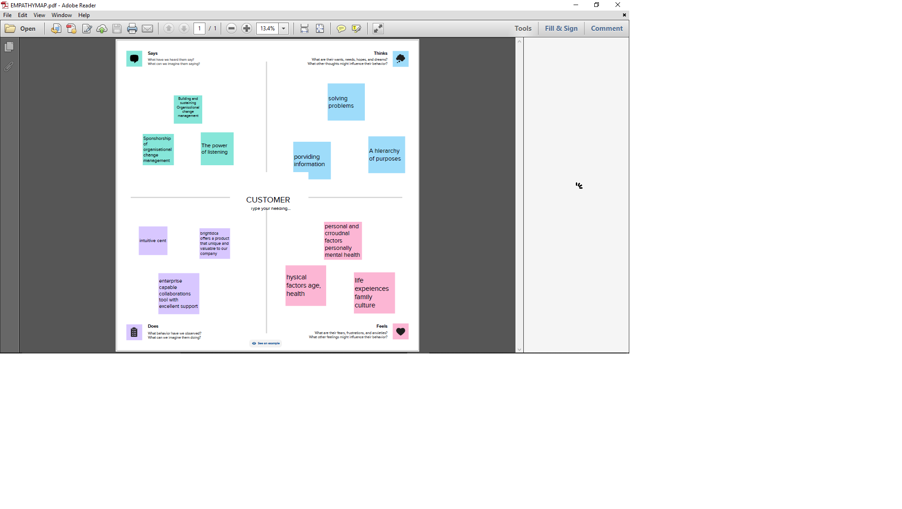

* 1. **Brainstroming Map**

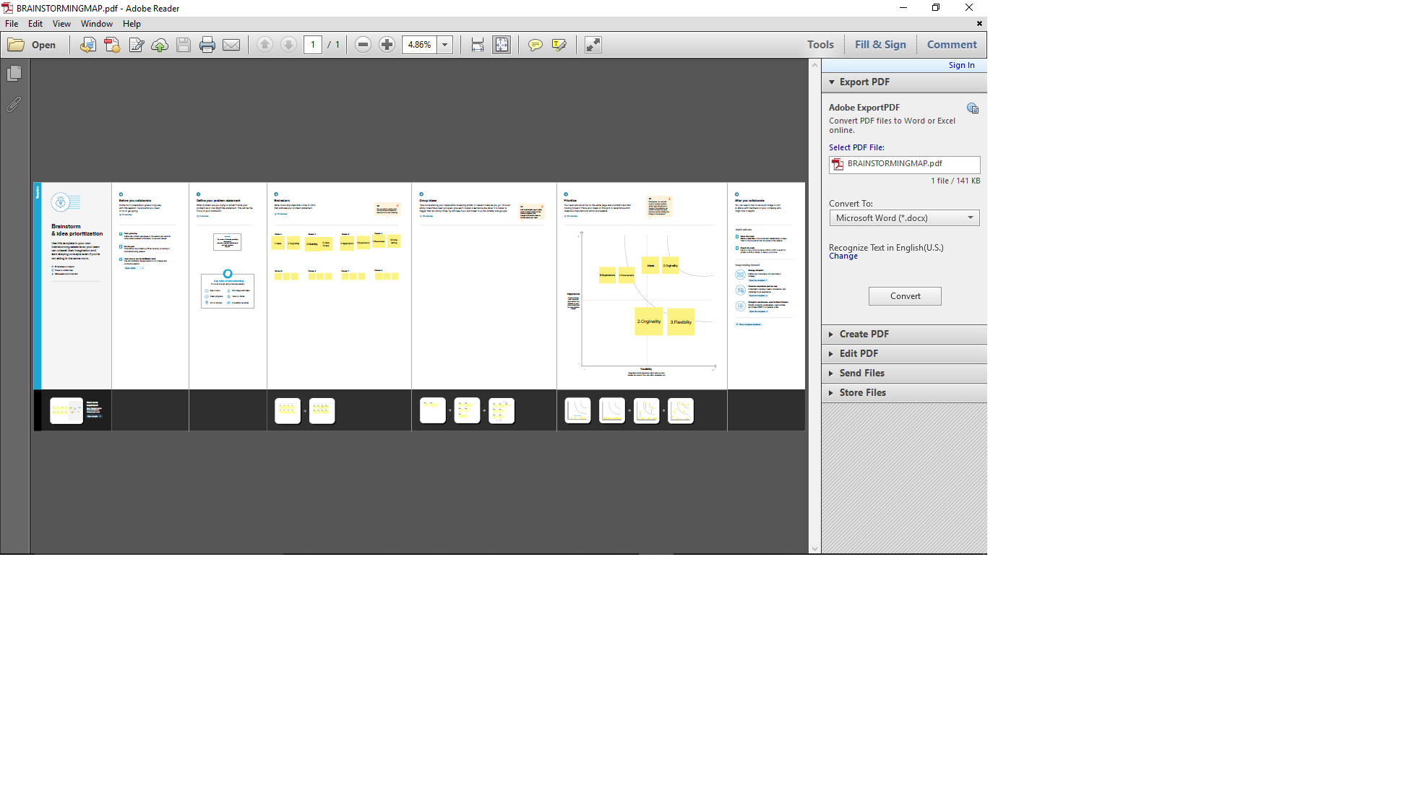

**3. RESULTS**

His bright idea turned out to be the incandescent light bulb, which he invented in 1880. My bright idea for a high-tech gift for this holiday season is actually a 19th century invention: a light bulb

**PROFIT AND LOSS**

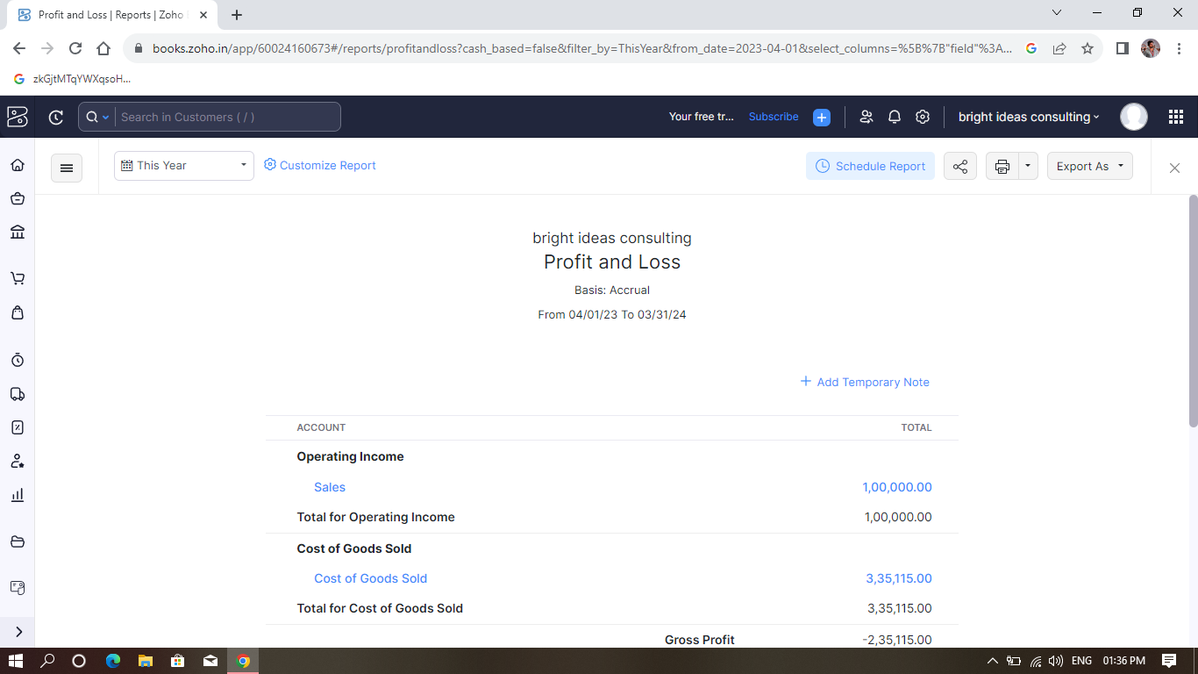

**BALANCE SHEET**

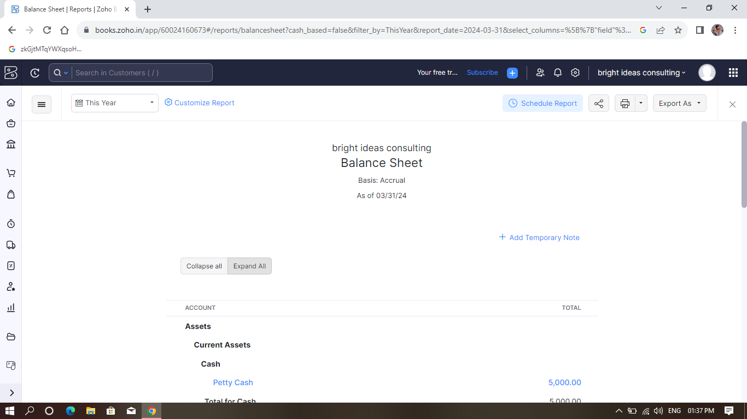

**GST REPORTS**

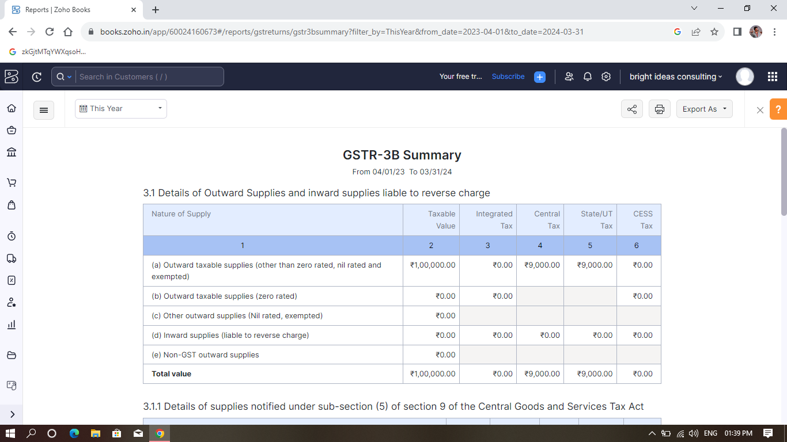

**TEX RETRUN**

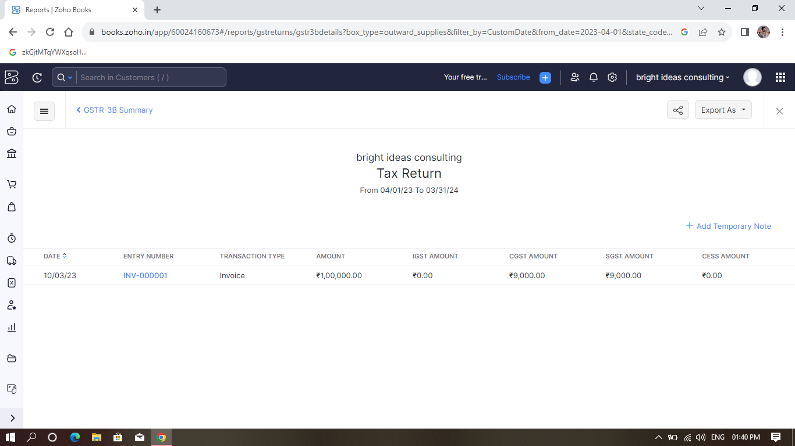

**JOURNAL REPORT**

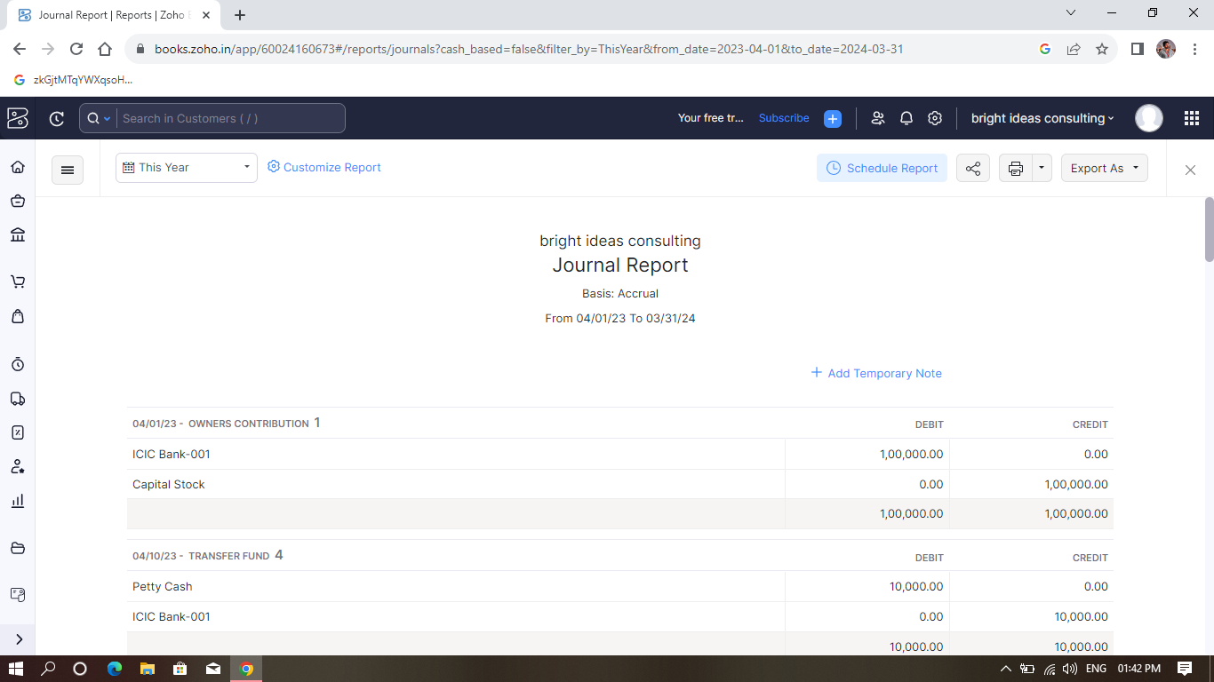

**ACCOUNTS PAYABLE AGING DETAILS**

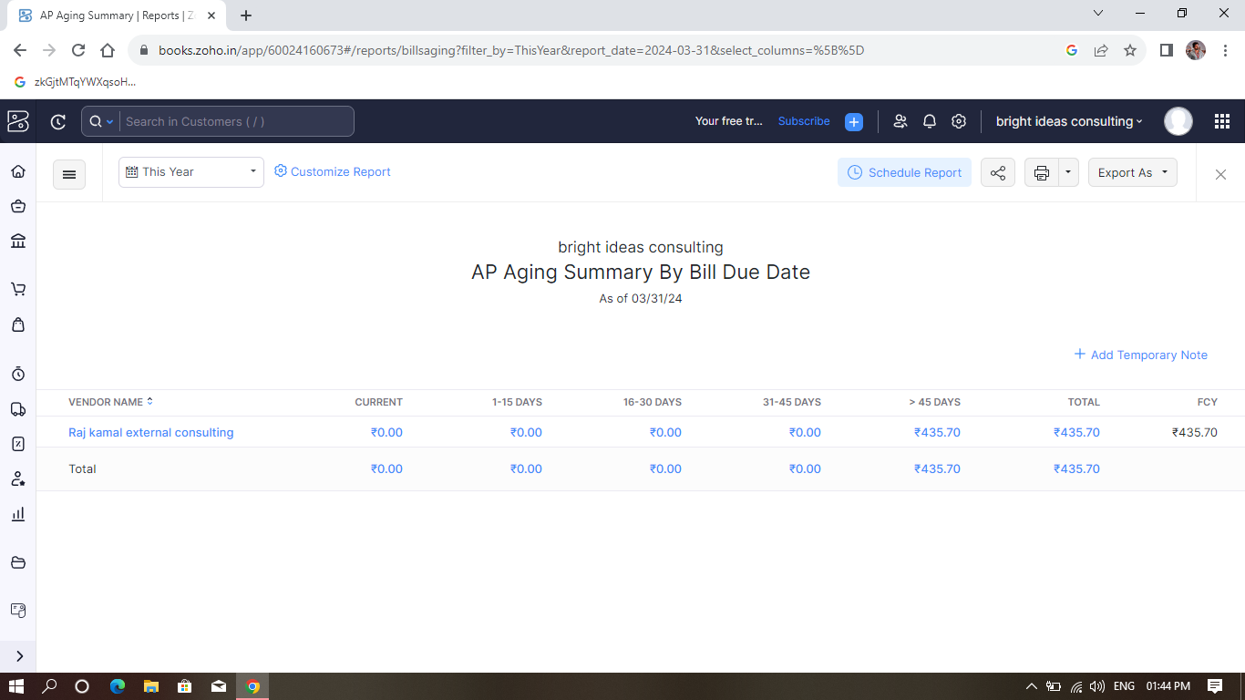

4**. ADVANTAGES AND DISADVANTAGES**

**Advantages**

1. Innovative Solutions: Bright Ideas Consulting is likely to offer innovative solutions to various business problems, leveraging their expertise and creativity.

2. Expertise: Consultants often possess specialized knowledge and skills that can benefit businesses, providing insights that may not be available within the organization.

3. Objective Perspective: External consultants can offer an unbiased, objective perspective on business issues, which can be valuable for decision-making.

4. Efficiency: They can streamline processes, increase efficiency, and optimize operations, leading to cost savings and improved productivity.

5. Flexibility: Businesses can hire consultants on a temporary basis, providing flexibility in managing workloads and addressing specific challenges.

**Disadvantages**

1. Cost: Hiring consultants can be expensive, especially for small businesses with limited budgets. The cost may outweigh the benefits for some organizations.

2. Dependency: Excessive reliance on consultants can create dependency issues, where the organization becomes reliant on external expertise rather than developing internal capabilities.

3. Confidentiality Concerns: Sharing sensitive information with external consultants may raise concerns about confidentiality and data security.

4. Implementation Challenges: Recommendations made by consultants might face resistance during the implementation phase within the organization, leading to challenges in realizing the proposed benefits.

5. Lack of Understanding: External consultants may not fully grasp the unique internal dynamics and culture of the organization, potentially leading to recommendations that are not a good fit for the company.

**5. APPLICATIONS**

When applying for a specific consulting project at Bright Ideas Consulting, it's important to tailor your application to the project's requirements. I am writing to express my keen interest in the bright ideas consulting position at Bright Ideas Consulting

**6. CONCLUSION**

In conclusion, I am enthusiastic about the opportunity to join the Bright Ideas Consulting team and collaborate on the [Specific Consulting Project Name]. My background and experiences have prepared me to make a meaningful impact, and I am eager to contribute my expertise to drive the success of this project.

**7. FUTURE SCOPE**

The future scope for a consulting project undertaken by Bright Ideas Consulting can be diverse and can evolve based on market trends, client needs, and the company's strategic direction. Here are some potential future scopes and growth opportunities for such a consulting project:

1. Expansion into New Markets

2. Diversification of Services

3. Technology Integration

4. Industry Specialization

5. Innovation and R&D

**8. APPENDIX**

A. Source Code